The Effect of Proximity to Universities on Housing Prices in Peninsula Halifax

Honours Thesis

Joel Robitaille

April 2017

Abstract

This paper examines the connection between proximity to universities and the value of dwellings in the Halifax peninsula. To assess this relationship data on physical and location characteristics of all dwellings in the study area are collected, and a regression of dwelling values against these characteristics is conducted. The study finds that there is a significant and substantial positive relationship between proximity to universities and housing values in the peninsula of Halifax.

Keywords: housing prices, location, university

JEL Numbers: R21, D12

*1. Introduction*

The theory of urban location, which predict higher demand and housing cost with respect to proximity to job centers as consumers attempt to minimize their total location costs is well established by Alonso (1960) and Evans (1973), and it has been studied in a number of settings. In most of these studies the central business district is taken as the job centre of choice. In spite of the fact that universities in many ways function in a similar manner, there is far less consideration given to how they act as economic focal points and their effect on property values of surrounding areas. This paper seeks to answer the question of what is the connection between proximity to universities and the value of dwellings by examining the Halifax peninsula. The results contribute to understanding the distribution of housing values in Halifax, and other communities with large universities. The results can also give clues as to how significant the factors that drive the importance of proximity to a university are to the determination of housing values. A large positive relationship between proximity and dwelling values may also be an indication of a supply imbalance in areas surrounding universities.

One approach to assess this relationship is to collect data on the average dwelling values of neighbourhoods for which statistical information is maintained, such as census tracts, and conduct a simple regression of these values against the estimated distances to the nearest university. The drawback of this approach is that it does not allow for control of variations in individual housing characteristics. Therefore, this type of analysis is of limited analytical use. To overcome this issue this research instead collects microdata on the values and characteristics of all individual dwellings in the study area. This research design allows for an examination of the effect of changes in the distance to the nearest university, while controlling for variation in other dwelling characteristics.

This paper will survey the existing literature on location based housing valuation, and describe in detail the conceptual framework of the factors expected to be at play in the housing market. The paper will then describe the sources of microdata, how the relationship between the key variables is observed, and present the findings. The conclusion will tie together the outcome of this analysis and present some suggestions for further study.

*2. Background and related literature*

The basic theory of housing valuation as summarized by Glaeser (2007) states that the value of a dwelling like any other product is related to a series of characteristics that determine its desirability to a potential consumer. Since housing is often an investment product, a speculation premium is also added to its price (Sun, Zheng and Wang 2015). Glaeser (2007) elaborates that, all other things being equal, including geographical features and housing size, the primary driver of housing demand is distance to the center of employment as potential residents attempt to minimize their total location costs.

A complete model of housing prices incorporates a larger range of dwelling characteristics. These are split into the physical characteristics, such as, square feet of living space, number of bathrooms and connection to city services; and location characteristics, such as proximity to parks, elementary schools, or distance to the economic activity center (Do-Yeun 2009).

Do-Yeun (2009) identifies a number of empirical studies that have been completed to assess the impact of location based amenities, such as elementary schools (Jud 1985) and parks (Weicher 1973) on housing value. In almost all cases, a positive relation between proximity and price is identified.

A common approach used to assess the contributions of various characteristics to housing value is the hedonic model, which is described in detail in Rosen (1974). In a hedonic regression one gathers product price information for various versions of a product for which component characteristics differ and then regresses the values against variation in the characteristics to isolate how each characteristic contributes to value. In this research paper, the characteristic of interest is distance to the nearest university.

There have been several studies conducted on the relation of the proximity to the central business district and housing values, some of which used a hedonic model, which are surveyed by Glaeser (2007). The majority of these identified positive relationships between values and proximity, but Glaeser (2007) notes that in some case the relationship is complicated by the existence of other factors determining value, and in other cases the studies were limited by methodological constraints.

To my knowledge, literature regarding the impact of proximity to a university as an economic focal point, is very limited. Do-Yeun (2009), who examines the effects of proximity to Purdue University on apartment rents, is one of the primary authors to have studied this. In the result of his regression analysis Do-Yeun shows a significant and substantial relationship between proximity to Purdue University and apartment rents in Lafayette. This paper differs from Do-Yeun’s in that the aim is to study the effect of proximity on housing prices and not rents. I hope to find whether a pattern similar to the one identified by De-Yeun repeats itself for housing prices in Halifax.

*3. Conceptual framework*

The justification for including proximity to a university as a characteristic that is expected to drive value is based on a model that makes a series of suppositions. The first is that housing demand increases as one moves closer to an economic focal point. The second is that due to the finite quantity of land at a given location, increasing per unit costs of construction (Evans 1973), and planning regulation that restrict supply, the supply of housing in a fixed area is inelastic to price in both the short and long-run. The third is that, in addition to impacting the market directly in the owner-occupier market, higher demand also impacts prices indirectly through higher rents which lead to higher asset values. The fourth is that the universities in Halifax’s south end act as economics focal points of the type mentioned in the first assumption. The first three suppositions are well supported by established economic theory and evidence. The fourth is a permutation of the economic theory urban location, where the economic focal is a university rather than a central business district.

The first point relates to the theory of urban location, as described by Evans (1973), which states that the determination of a consumer’s location preference is based on minimizing her total location costs. Total location costs consist of two parts: actual housing cost - the rent, or mortgage for a given dwelling - and travel costs to an individual’s job or daily activity. Travel costs are split into direct travel costs, such as gas and car ownership, and the time costs of commuting. Although a large part of the population being considered the this scenario are students and not full-time employees, for students attending school full time and making their own accommodations decisions, proximity to the university campus occupies a similar importance in the cost minimization decision as it does for an employed person.

In its simplest form the location preference model developed by Alonso (1960) presupposes that all individuals in a city work in one central location and that direct and indirect transportation costs increase as one moves away from this location. While the extreme assumption of a monocentric distribution of employment is not representative of reality, it is a good jumping off point for a model. In the literature Alonso (1960) and Evans (1973) acknowledge the possibility of multiple centres of employment affecting the distribution of demand, and incorporating these into the model. Universities are not always thought of as economic centres but in terms of their draw on commuters they function in much the same way. The universities of the Halifax peninsula have a large population that commutes to them on daily basis. Based on official number published by the Association of Atlantic Universities there were a combined 23,134 full time students enrolled at Dalhousie University’s Halifax campuses and Saint Mary’s University in 2016-17. Info from the websites of Dalhousie and Saint Mary’s states that there are also 7,737 current staff members between the two institutions. Figure 1 shows the breakdown of these populations. These student and staff populations represent a substantial concentration of people commuting to destinations in the south end on a daily basis, especially compared to the total population of the peninsula of around 65,000. This therefore represents a large amount of additional demand in areas near universities.



Figure 1: Full–time student in 2016-17 and staff for Dalhousie University’s Halifax campuses and Saint Mary’s University

The next question is how important is it for university students and staff to live close to campus. There are a number of reasons why the advantages to being close to campus may in fact be greater for students than the advantages for the average employee of being close to their place of work. One is that students attending urban universities generally have lower car ownership rates than the general population, making their commuting more expensive in terms of time. In a 2014 study of ‘Travel Behaviour of Dalhousie Commuters’ the Dalhousie Transportation Collaboratory found that, of 709 student respondents, only 11.9% drove to school as their primary mode of transportation (Habib 2015). The same study showed that 34% of all respondents, and 51.3% of students, walked to school as their primary form of transit. This is a commuting pattern that relies much more heavily on short distance transportation methods than the average for metropolitan population. The value of proximity may also be of elevated for student because there are social and academic environmental benefits to being on or near to the campus community. A large amounts of student social, extracurricular and after-class studying activities are focused on campus and there are increased costs in terms of transportation time or forgoing these activities for students who live farther away from campus. Kuh et al (2001) find that students living on or near campus score higher on a host of success indicators, including academic engagement, compared to those who commute from long distances. It is my contention that many students realize this and that it is another factor that drives demand for being closer to the university campus.

There is also some concrete evidence that students and staff have a tendency to live closer to campus. In the map in Figure 2, which shows the locations of student and staff respondents to DalTRAC’s 2010 Dalhousie Commuter Survey, shows a concentration of respondent living in the 2km buffer surrounding the university, and elevated concentration in specific neighbourhoods near the universities (IBI Group 2011).

The more current 2014 Dalhousie Commuter Survey (Habib 2015) reports that 47.1% of student respondents live within 2km of their campus. It also reports that 71.5% of students, 46.9% of faculty but only 23.7% of staff live within 5km of their campus. This shows that both a high proportion of students and faculty choose to live close to campus and also highlights the idea that the propensity to live near campus for students and faculty is elevated compared to staff.

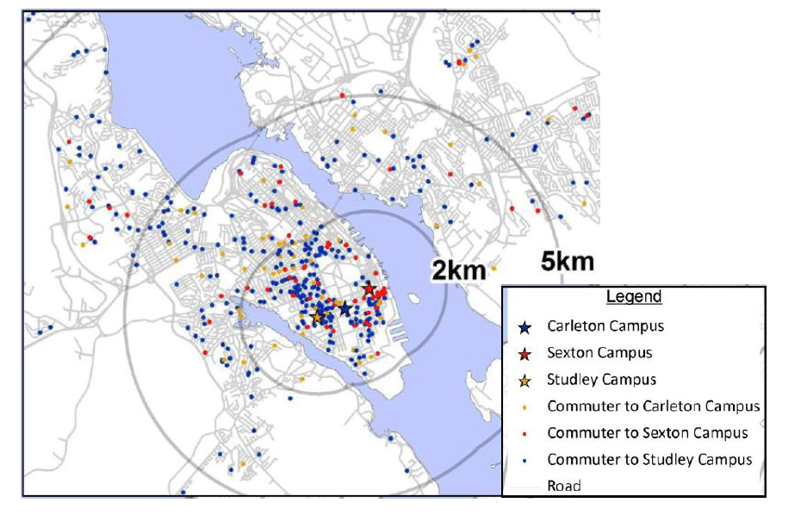

Figure 2. Residential location of respondents to the Dalhousie Commuter Survey. Source: 2012 Dalhousie Transportation Demand Management Plan

One factor that could influence this relationship would be if there were location based characteristics correlated with proximity to the universities that were also negatively (or positively) correlated with housing desirability. A classic example is a concentration of industrial activity near the city centre, where its presence makes neighbourhoods less desirable to many potential residents. In the study area there are not many areas for which this would be a factor, with one possible exception being the small pocket in the eastern portion of the south end where some vestiges of the port based industrial activity remain.

Another important factor to consider is proximity to positive amenities, such as large parks or P-12 schools. Upon reflection I have noticed that there is a concentration of high value dwellings in the areas surrounding Point Pleasant Park on the southern tip of the peninsula. Because this is close enough to some universities, in particular Saint Mary’s, it is possible that for some houses, proximity to the park is a factor driving values and that this upwardly biases the estimate of the effect of proximity to a university. Weicher and Zerbst (1973) find evidence that parks do drive housing values so in future studies it would be beneficial to include a variable for proximity to major parks.

Finally, some may suggest that proximity to the waterfront is an important variable to include in a model of housing prices, especially in a study area like the peninsula of Halifax where a large amount of properties are on, or near to, the waterfront. While there is good reason to believe that proximity to the shoreline increases dwelling value, failing to include it in the model should not a critical omission for this study. The reason for this is that none of the peninsula universities are located on the coast – they are all in-land - and therefor exclusion of proximity to the waterfront should not upwardly bias estimates of the effect of proximity to universities on dwelling values.

There are a number of location based characteristics other than proximity to a university or proximity to the central business district that one could expected to influence dwelling value. In some cases inclusion of these variables could improve the model. However, none of these location features are completely collinear with proximity to universities and the direction of the effects are not all the same, so it is my opinion that not including them does not substantially affect the general validity of the findings.

The second major assumption of the model is that predicted higher demand translates to higher housing prices. There are two mechanisms through which higher prices could attain. The first, obvious one, is that in the market for owners-occupiers, buyers with a desire to be closer to the university would bid up prices for houses near to universities. These buyers would most likely be faculty members, and possibly some staff member, who would like to be close to the university. The second, less obvious but likely more important method in which demand drives prices is through student demand for rental accommodations. The idea is that higher demand bids up rent prices near universities, which is exactly what Do-Yeun (2009a) found in his study of rent prices in Layfette with respect to proximity to Purdue University, and these higher rent prices, in so far as they are an income stream, increase the asset values of homes that are rented. There has been a broad consensus among those studying the connection between rents and housing prices, including Campbell (2009), Clark (1995) and Meese and Wallace (1994), that in the long run housing prices reconcile to rents based on a dynamic Gordon growth model, which assess housing value as the present value of future rents, including expected rental growth and allowing for changes in the discount rate. There is ample evidence that large amount of the housing stock in the areas surrounding universities has been converted to rental accommodations. A short walk through the Halifax’s south-end will reveal that dwellings that were once private homes and have been converted in income rental apartments are ubiquitous. In addition to higher rents leading to elevated values for income properties they could also have an upward influence on the value of private dwellings. This is because, where the markets coexist, any private dwelling can theoretically be converted into an income property. The asset values of income properties minus conversion costs set a floor for the value of private dwellings in the same area.

The final supposition of the model, and an important one, is that supply is restricted due to a finite amount of land available at any given distance from the universities, increasing per unit development costs, and restrictions on adding supply in the form of municipal planning regulations. The result is that increased prices do not generate a full supply response and elevated demand translates through mostly in the form of higher prices.

To summarise the conceptual framework for why proximity to universities is expected to be related to higher dwelling values: in our model university students and staff generate increased demand related to proximity to universities. Coupled with inelastic supply of housing this is expected to lead to elevated housing prices directly through the owner-occupier market and indirectly though elevated rents in the areas near universities.

*3.1 Empirical Method*

The relationship between the distance a university and dwelling value will be estimated by comparing the prices of like dwellings while varying the distance to the university and holding other characteristics constant. This will be done by conducting a hedonic regression of housing prices on the network distance to the nearest university and other dwelling characteristics. For this to be effective it is important to be able to compare dwelling that are alike in almost all regards except their distance to a university. To allow for this, the research design includes variables for number of bedrooms, number of washrooms, square footage of total dwelling / number of bedrooms, dummy variables for construction quality, the inclusion of a garage and the inclusion of a finished basement, and a second location variable for distance to the city center. The inclusion of these additional regressor in the research design is expected to allow the regression to isolate the effect of proximity to universities on housing values.

The study separates and excludes large apartment buildings. The reason for this is that there cannot be an effective comparison between large apartment buildings owned by real-estate corporation and individual dwellings that can be owned by individuals.

*4. Data Sources*

Microdata on the value of individual dwellings in the study area comes from Property Value Services Corporation (PSVC), the official property assessment organisation for Nova Scotia.[1] Data for the 2016 assessed values of dwellings is gathered from the Nova Scotia-wide file. The PVSC’s assessed values are meant to be a representation of market value and are arrived at by taking an average recent sales prices in the neighbouring area and adjusting for dwelling specific characteristics. It is important to distinguish this from the “capped assessment value”, which is different in that it is not necessarily based on market value. To determine the fidelity of the assessed values, an assessment of the delta between 2016 assessed value and actual sales values is conducted using 2016 sales data from PVSC and finds that on average assessments are relatively close to sales values, approximately $18,000 above. Based on this it is believed that assessed values are a reasonable representation of actual market values.

In addition to assessed values, PVSC also has data on a number of dwelling characteristics including number of bedrooms, number of bathrooms, square feet of living space, construction quality, and the existence of a garage or a finished basement. These data on physical housing characteristics are retrieved and windowed to the study area. They are then matched to predictor variables that are expected to contribute to the dwelling value.

For the location variables, data for the network distance of each dwelling to the nearest major university are calculated in ARCGIS using the geographic location of each civic address, a road-network layer and the network analyst tool. This gives the distance in metres to the nearest campus. Distances are calculated to the centroid of the campus, while applying a cost layer to the campus boundary whereby after crossing the campus border distances are added at 10% of the their actual amount. This has the effect of making all dwellings on campus recorded as being at approximately zero distance from the university. A similar calculation was done for the distance to the central business district, where distance where calculated to city hall and a reduced cost layer surrounding the downtown core with 30% cost for distances within the core was used.

Figure 3: Representation of the network distance from each civic address to the nearest university.

Data from the distance calculation files, which included all civic address on the peninsula, and the dwelling characteristic file, which included all residential dwellings for the community of Halifax were merged to create a file of all residential dwellings on the peninsula of Halifax. Outliers in this data set were identified an examined to determine if they met the criteria of the study population, and included or removed as appropriate.

*4.2. Research Design*

To answer the research question of whether there is a statistically significant positive relationship between the proximity of dwellings to a university and their value, the above mentioned micro-data for all residential dwellings in the study area of the peninsula of Halifax are gathered and mapped to variables that are expected to contribute to dwelling value. The analysis them regresses the assessed value of the dwellings against the predictor of interest, the distance to a university, and the other physical and location characteristic.

The full regression model is:

Where, i = 1,…,n and consists of residential properties in the study area.

The physical and location characteristics used are those stated in the empirical framework and listed above, and summary statistics of these variable are presented in Table 1.

*5. Results*

In all iterations of the regression *Distance to Nearest University* is significant at the 99% confidence level and appears to be one of the primary drivers of housing values. All regression results are reported in Table 2 in the appendix. In the basic univariate regression, the estimated average change in housing value related to being 1km closer to a university is $76,832. The general relationship can be seen in the plot in Figure 5 where one can see a general trend of increase in values especially between 2.5km and 0.5km from the nearest university, with some high outliers in the range of 1.5km to 0.5 km distance. It should be noted that the coefficients for *Distance to University* in the regression results in Table 2 are negative, which is the opposite of the way they are being discussed here. The regression results table co-efficient has the literal interpretation of being the decrease in value as one moves away from the nearest university, but for the sake of day-to-day interpretation I present the results as the increase in value as one moves closer.

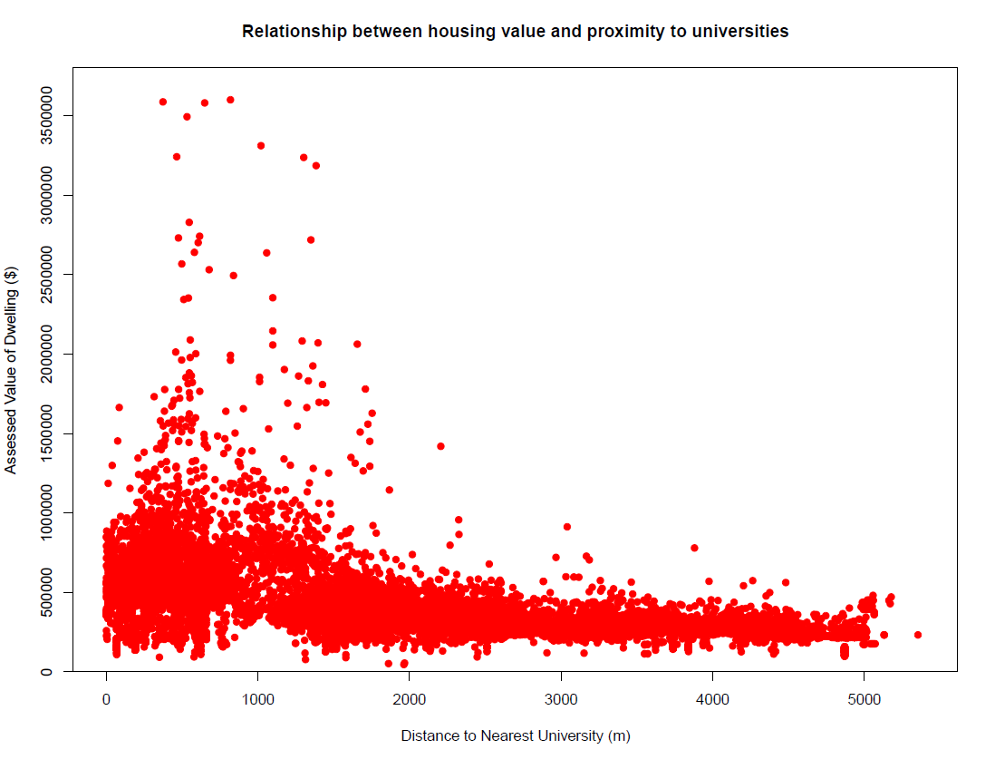

Figure 4: plot of data points for distance to the nearest university against assessed values

Urban location theory suggests that the first step in adding detail to model should be to add a regressor for the distance to the central business district, because proximity to the downtown core is predicted to be positively related to housing values and in Halifax the distance to the downtown core is fairly collinear with distance to universities. In a surprising result, in the bivariate regression of values against the distance to the nearest university and distance to the central business district, the estimated effect of being closer to downtown core is negative for the Halifax peninsula. In Model 2 average values decrease by $109,005 for every 1 km one moves closer to the core. This also shows that the initial exclusion of the distance to the central business district negatively (rather than positively) biased the estimate for the effect of proximity to universities. In Model 2 the average value of dwellings increases by a staggering $142,421 for every 1 km one moves closer to the nearest university.

There are some valid economic interpretations for the negative relationship between price and proximity to the central business district. For a study area as small as the peninsula of Halifax, which has a maximum distance to the central business district of 5.2km, it could be said that for the purposes commuting to work once a day or going to the downtown core occasionally for amenities, all locations in the peninsula are effectively “close” to the downtown core. It could be the case that, while there is a value to being within a certain proximity of the downtown, the average peninsula resident also prefers to be in neighbourhoods slightly removed from the business of the downtown core. A previous study of average housing values for census tracts in Halifax Regional Municipality (Robitaille, 2016) finds this to be true. For locations greater than two kilometres from the downtown core the gradient of housing prices increases with proximity, but for locations less than 2 kilometres away the relationship is less clear and essentially reversed.

To further refine the validity of the estimate, data for physical characteristics that are expected to be crucial in determining the value of a dwelling are added to the regression. Models 3 and 4 include variables for number of bedroom, number of bathrooms, spaciousness, and dummy variables for construction quality, whether the property has a garage, and whether it has a finished basement. Model 4 differs from Model 3, in that it is a regression of the natural logarithm of assessed values on characteristics. This gives the coefficients the interpretation of being percentage changes in assessed value for unit changes in the characteristic variables. It is included because, in general, this better models the way changes in characteristics are relate to changes in housing values. In Models 3 and 4 average housing values increase by $94,629 and approximately 20% for every 1 km closer to a university. As expected, the estimate of the effect of proximity to universities is slightly lower when controlling for physical characteristics. This was expected because of the concertation of larger size dwelling in the south end neighbourhoods. What is surprising is that after controlling for physical features, the estimate remains as large as it is. This finding is significant at the 99% level in both models, with a standard error of $1,837 per km in Model 3.

*Other determinants of value:*

Many of the other characteristic are also shown to be strong predictors of dwelling values. Increasing the number of bedrooms by one increases average dwelling value by $29,648 or approximately 5.8%. Similarly, an increase in the number of bathrooms by one is related to an increase in average values of $37,182 or approximately 6.2%. Although these are big on their own, compared to the effect of moving 1 km closer to a university these are surprisingly small in proportion. One would have to add three bedrooms or almost three bathrooms to add value equivalent to the average increase related to being 1 km closer to a university. This shows that, on average, housing consumers on the peninsula value location amenities more than increases in size characteristics, like the number of bedrooms or bathrooms.

The measure of spaciousness, defined as square feet divided by number of bedrooms is also substantial driver of dwelling values. An increase in spaciousness of 100 square feet / bedroom is related to a $26,632 increase in average dwelling values. This estimate, as well as those for number of bedrooms and number of bathrooms, are all significant at the 99% confidence level. These show that the basic variables relating to housing size play an important role in determining housing value in addition to other factors.

The R squared for the regression in Models 3 and 4 are 0.684, and 0.799 respectively. This shows the models explain a large amount of the variation in housing values across the peninsula. The magnitude and significance of the estimate for the effect of proximity to the nearest university establishes that this is a significant relationship in the peninsula of Halifax. The coefficients for all the predictor variables, with the exception of the presence of a finished basement, are also significant at the 99% level in Model 4.

*Sensitivity Analysis*

One argument that could be made against the robustness of the estimates in this study is that there are a large number of high value dwellings in the certain parts of the south end, in particular around Point Pleasant Park and the Northwest Arm, whose premium value may be driven by some characteristic other those included in the regression. If that were true, the fact that these neighbourhoods are more close than they are far from the peninsula’s universities would mean that these unobserved drivers inflate the estimate of proximity to a university. The omitted factors driving value may be proximity to Point Pleasant Park or they may be a neighbourhood characteristic related to being located among other high value dwellings. While it was not possible in the study to include a variable for distance to major parks or find a control for spatial heterogeneity, it is possible to examine what the results of the analysis are if we exclude all dwelling with an assessed value over $1,000,000. Model 5 eliminates 282 dwellings with values over $1,000,000 from the original population. The result is that excluding these high value dwellings reduces the estimated effect of proximity to universities by about $13,000/km. In Model 5 the average effect of moving 1 km closer to a university is a $81,978 increase in dwelling value. Although is less than in Model 3, the relationship between proximity to universities and dwelling values remains strong even when omitting the highest value dwellings. This shows the relationship identified is not overly influenced by pockets of high value neighbourhood in the south end.

*6. Conclusion*

This research paper aimed to find the connection between proximity to universities and housing values. To find this, micro data on the assessed values and associated physical and location characteristics of each dwelling on the peninsula of Halifax were collected. These were used to conduct a regression of values on the characteristics. The resulting coefficients give us estimates for the average contribution of a unit change in each characteristic to dwelling value. Controlling for most physical characteristics and the network distance to the downtown the results show there is a strong relationship between proximity to universities and dwelling values in the peninsula of Halifax.

This finding is important for agencies trying to understand dwelling values in markets with large universities and large university populations. The strength of the relationship, when compared to some physical characteristic predictors, suggest that it may be valuable to include distance to a university as variable in determining property value assessments. The findings of this study are also important in terms of understanding the distribution of dwelling values in Halifax, how it came about and what factors affect it. Finally, the strength of the relationship gives some information about how changes in the amount of university based housing demand may affect housing markets in the areas near universities.

*Appendix*

|  |  |  |  |  |  |
| --- | --- | --- | --- | --- | --- |
| Table 1: Descriptive statistics of regression variables | | | | | |
|  | | | | | |
| Variable | N | Mean | St. Dev. | Min | Max |
|  | | | | | |
| Assessed Value (2016) | 13,282 | $414,755 | $237,088 | $46,600 | $3,599,900 |
| Number of Living Units | 13,282 | 1.3 | 0.7 | 1 | 15 |
| Age | 10,461 | 64.1 | 32.3 | 1 | 201 |
| Square Feet of Living Area | 10,223 | 1,937.9 | 904.6 | 399 | 11,467 |
| Sq. ft. / # Bedrooms | 9,630 | 549.9 | 237.2 | 123.8 | 5,760.0 |
| Bedrooms | 12,450 | 3.2 | 1.5 | 1 | 24 |
| Bathrooms | 13,097 | 2.0 | 1.0 | 1 | 17 |
| Average Quality Dummy | 10,224 | 0.5 | 0.5 | 0 | 1 |
| Good Quality Dummy | 10,224 | 0.4 | 0.5 | 0 | 1 |
| Very Good to Excellent Quality Dummy | 10,224 | 0.0 | 0.1 | 0 | 1 |
| Finished Basement Dummy | 13,282 | 0.3 | 0.5 | 0 | 1 |
| Garage Dummy | 13,282 | 0.2 | 0.4 | 0 | 1 |
| Distance to Nearest University (m) | 13,282 | 1,828 | 1,362 | 2 | 5,353 |
| Distance to Central Business District (m) | 13,282 | 2,366 | 1,053 | 316 | 5,189 |
|  |  |  |  |  |  |
| Total number of observations | 13,282 |  |  |  |  |

|  |  |  |  |  |  |
| --- | --- | --- | --- | --- | --- |
| *Table 2: Regression Results* | | | | | |
|  | *Dependent variable:* | | | | |
|  |  | | | | |
|  | Assessed Value | | | ln(Assessed Value) | Assessed Value |
|  | Model 1 | Model 2 | Model 3 | Model 4 | Model 5 |
| (Dwellings < 1M) | | | | | |
| Distance to University (m) | -76.832*** | -142.421*** | -94.629*** | -0.0002*** | -84.757*** |
|  | -1.355 | -2.03 | -1.837 | 0 | -1.08 |
|  |  |  |  |  |  |
| Distance to Central Business District (m) |  | 109.005*** | 78.161*** | 0.0001*** | 56.124*** |
|  |  | -2.626 | -2.515 | 0 | -1.483 |
|  |  |  |  |  |  |
| Number of Bedrooms |  |  | 29,648.100*** | 0.058*** | 25,528.190*** |
|  |  |  | -1,370.19 | -0.002 | -823.792 |
|  |  |  |  |  |  |
| Number of Bathrooms |  |  | 37,182.990*** | 0.062*** | 28,051.250*** |
|  |  |  | -1,941.74 | -0.003 | -1,189.02 |
|  |  |  |  |  |  |
| Sqft Living Area / Bedrooms |  |  | 263.632*** | 0.0004*** | 184.507*** |
|  |  |  | -7.933 | -0.00001 | -4.908 |
|  |  |  |  |  |  |
| Average Quality Dummy |  |  | 66,701.210*** | 0.206*** | 64,437.570*** |
|  |  |  | -6,385.08 | -0.009 | -3,721.35 |
|  |  |  |  |  |  |
| Good Quality Dummy |  |  | 138,795.700*** | 0.358*** | 133,235.600*** |
|  |  |  | -6,769.79 | -0.009 | -3,950.29 |
|  |  |  |  |  |  |
| Very Good to Excellent Quality Dummy |  |  | 592,682.900*** | 0.693*** | 245,115.400*** |
|  |  |  | -12,544.20 | -0.017 | -10,123.79 |
|  |  |  |  |  |  |
| Garage Dummy |  |  | 39,896.950*** | 0.081*** | 34,706.680*** |
|  |  |  | -3,112.35 | -0.004 | -1,839.01 |
|  |  |  |  |  |  |
| Finished Basement Dummy |  |  | -14,094.670*** | -0.005 | -715.473 |
|  |  |  | -3,182.51 | -0.004 | -1,890.14 |
|  |  |  |  |  |  |
| Constant | 555,190.600*** | 417,185.400*** | -9,237.50 | 12.112*** | 95,608.760*** |
|  | -3,089.28 | -4,415.91 | -10,401.46 | -0.014 | -6,229.20 |
|  |  |  |  |  |  |
|  | | | | | |
| Observations | 13,282 | 13,282 | 9,630 | 9,630 | 9,379 |
| R2 | 0.195 | 0.287 | 0.684 | 0.799 | 0.767 |
| Adjusted R2 | 0.195 | 0.287 | 0.684 | 0.799 | 0.767 |
| Residual Std. Error | 212,745.300 (df = 13280) | 200,161.800 (df = 13279) | 136,461.100 (df = 9619) | 0.185 (df = 9619) | 79,390.370 (df = 9368) |
| F Statistic | 3,214.200*** (df = 1; 13280) | 2,677.128*** (df = 2; 13279) | 2,086.825*** (df = 10; 9619) | 3,817.678*** (df = 10; 9619) | 3,083.296*** (df = 10; 9368) |
|  | | | | | |
| *Note:* | *p<0.1; **p<0.05; ***p<0.01 | | | | |

# Bibliography

Alonso, William. 1960. *Location and Land Use: Towards a General Theory of Land Rent.* Cambridge, Mass: Harvard University Press.

Campbell, Sean D., Morris A. Davis, Joshua Gallin, and Robert F. Martin. 2009. "What Moves Housing Markets: A Variance Decomposition of the Rent-Price Ratio." *Journal Of Urban Economics* 66 (2): 90-102.

Clark, Todd E. 1995. "Rents and Prices of Housing across Areas of the United States: A Cross-Section Examination of the Present Value Model." *Regional Science And Urban Economics* 25 (2): 237-247.

Do-Yeun, Park. 2009a. "Determinants of Market Rents in a Local Rental Housing Market." *Doctoral Dissertation, Purdue University* 1-20.

Do-Yeun, Park. 2009b. "Neighbourhood Effects of Rental Properties on Owner Occupied Housing." *Doctoral Dissertation, Purdue University* 45-69*.*

Evans, Alan W. 1973. *The Economics of Residential Location.* London: The MacMillan Press.

Glaeser, Edward L. 2007. "The Economic Approach to Cities." *The National Bureau of Economic Research.* doi:10.3386/w13696.

Habib, M.A. and M.H. Hafezi. 2015. *Travel Behaviour of Dalhousie University Commuters: An Analysis of Dalhousie Sustainability Survey 2014*. Halifax, NS: Dalhousie Transportation Collaboratory.

IBI Group. 2011. *Transportation Demand Management Plan for Dalhousie Unviersity.*

Jud, G. D. 1985. "A Further Note on Schools and Housing Value." *AREUEA Journal* 13: 452-562.

Kuh, George D., Robert Gonyea, and Megan Palmer. 2001. “The Disengaged Commuter Student: Fact or Fiction?” *Commuter Perspectives* 27: 2–5

Meese, Richard, and Nancy E. Wallace. 1994. "Testing the Present Value Relation for Housing Prices: Should I Leave My House in San Francisco?." *Journal Of Urban Economics* 35 (3): 245-266. *EconLit*, EBSCO*host* (accessed November 16, 2016).

Robitaille, Joel. 2016. "Examining the effects of distance from the city centre on housing values: an analysis of housing prices in the Halifax Census Agglomeration." Term paper for Econometrics 3338. Dalhousie University.

Rosen, Sherwin. 1974. "Hedonic Prices and Implicit Markets: Product Differentiation in Pure Competition." *The Journal of Political Economy* 82 (1): 34-55.

Sun, Weizeng, Siqi Zheng, and Rui Wang. 2015. "The Capitalization of Subway Access in Home Value: A Repeat-Rentals Model with Supply Constraints in Beijing." *Transportation Research: Part A: Policy and Practice* 80: 104-115.

Weicher, J. and Zerbst, R. 1973. "The Externalities of Neighbourhood Parks: An empirical Investigation." *Land Economics* 99-105.

1. PVSC recently released the records for all residential dwellings in Nova Scotia to the public as part of an open data initiative. The data can be accessed at www.datazone.ca.